NEWSLETTER

Every licensed provider helps complete Maine’s picture of today’s child care market.
Every three years, the Child Care Affordability Program asks licensed child care providers across Maine about their costs and prices. The information helps ensure that CCAP reimbursement rates reflect Maine’s child care market and informs other child care policy decisions.
The survey asks about providers’ costs, the number and ages of children served, participation in CCAP and other child care assistance programs, and the prices families pay for care.
Every provider matters. Even if you serve only a few children or do not participate in CCAP, your responses are important to ensuring an accurate picture of Maine’s child care market.
If you receive a Survey Invitation, please participate. Before beginning, download the Survey Preparation Checklist to gather the information you may need.
If you’ve misplaced your invitation, request a Replacement Personalized Survey Link through the Survey Landing Page.
Thank you for helping ensure that every program and every community are represented in the 2026 Maine Child Care Market Rate Survey.

Visit the Survey Landing Page


SOCIAL MEDIA TOOLKIT
Campaign 1: Early September
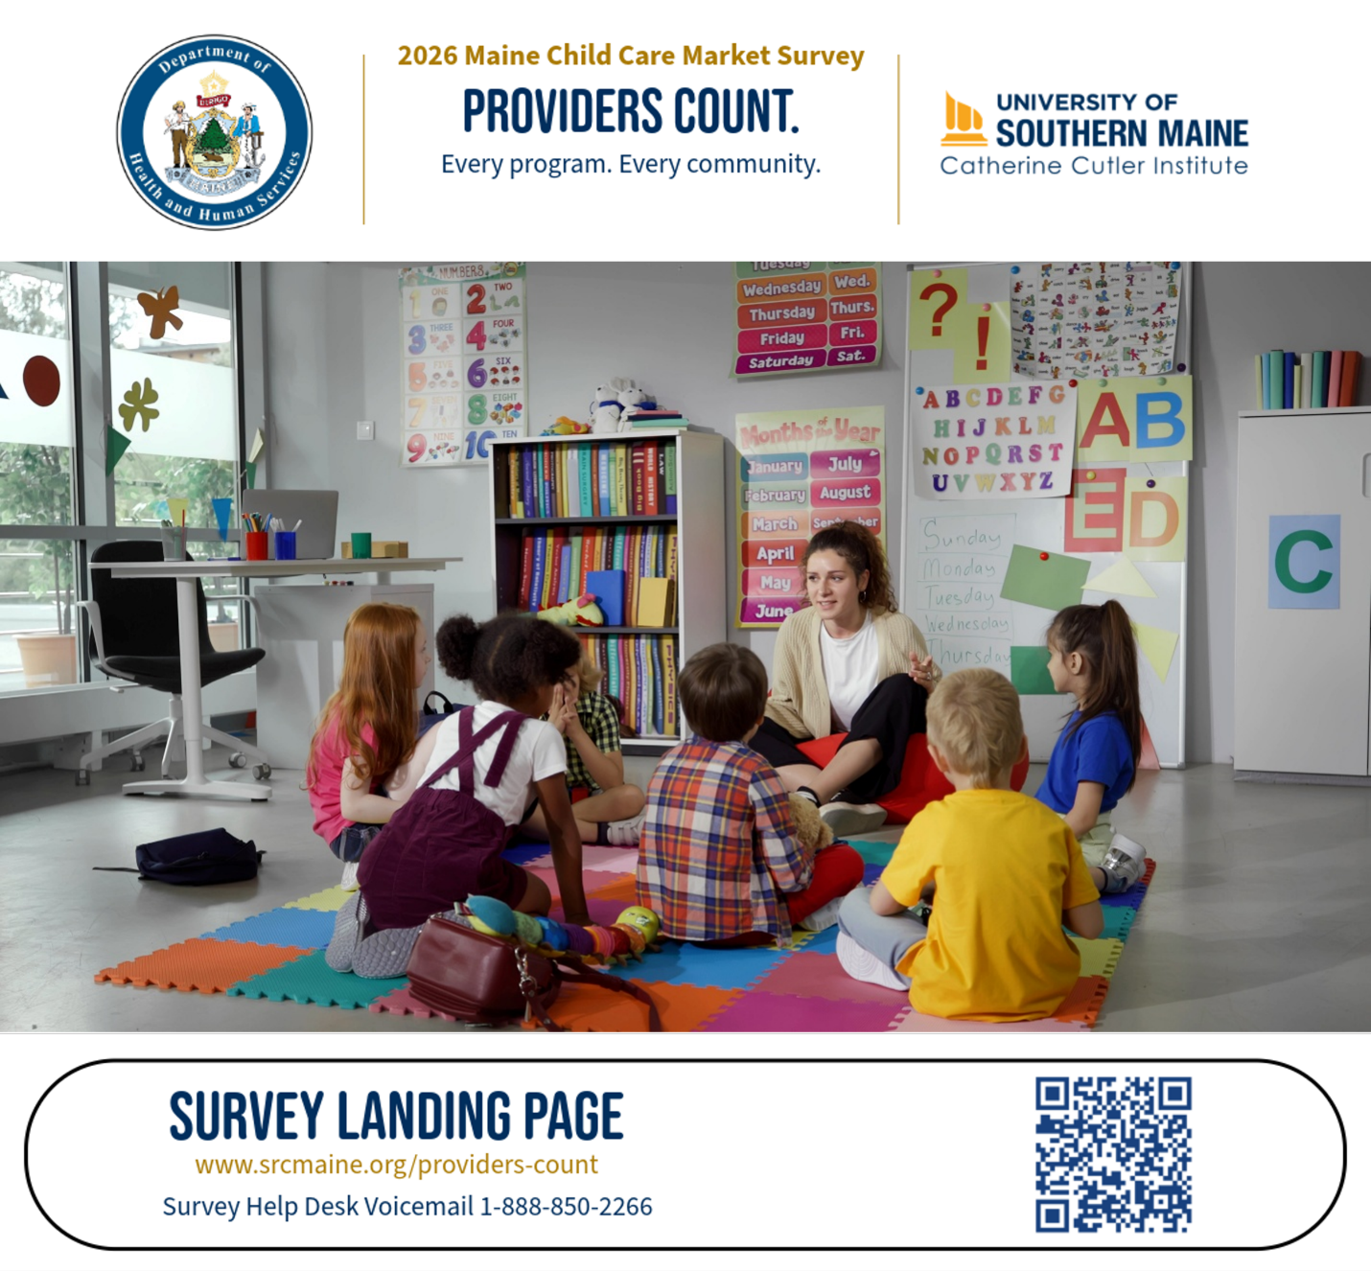

You know what it takes to provide quality child care.

Every day, you make decisions that support children, families, and your program. The 2026 Maine Child Care Market Rate Survey is your opportunity to share that experience and help inform future child care policy decisions.

Watch for your personalized survey invitation on September 1.

Campaign 2: Late September
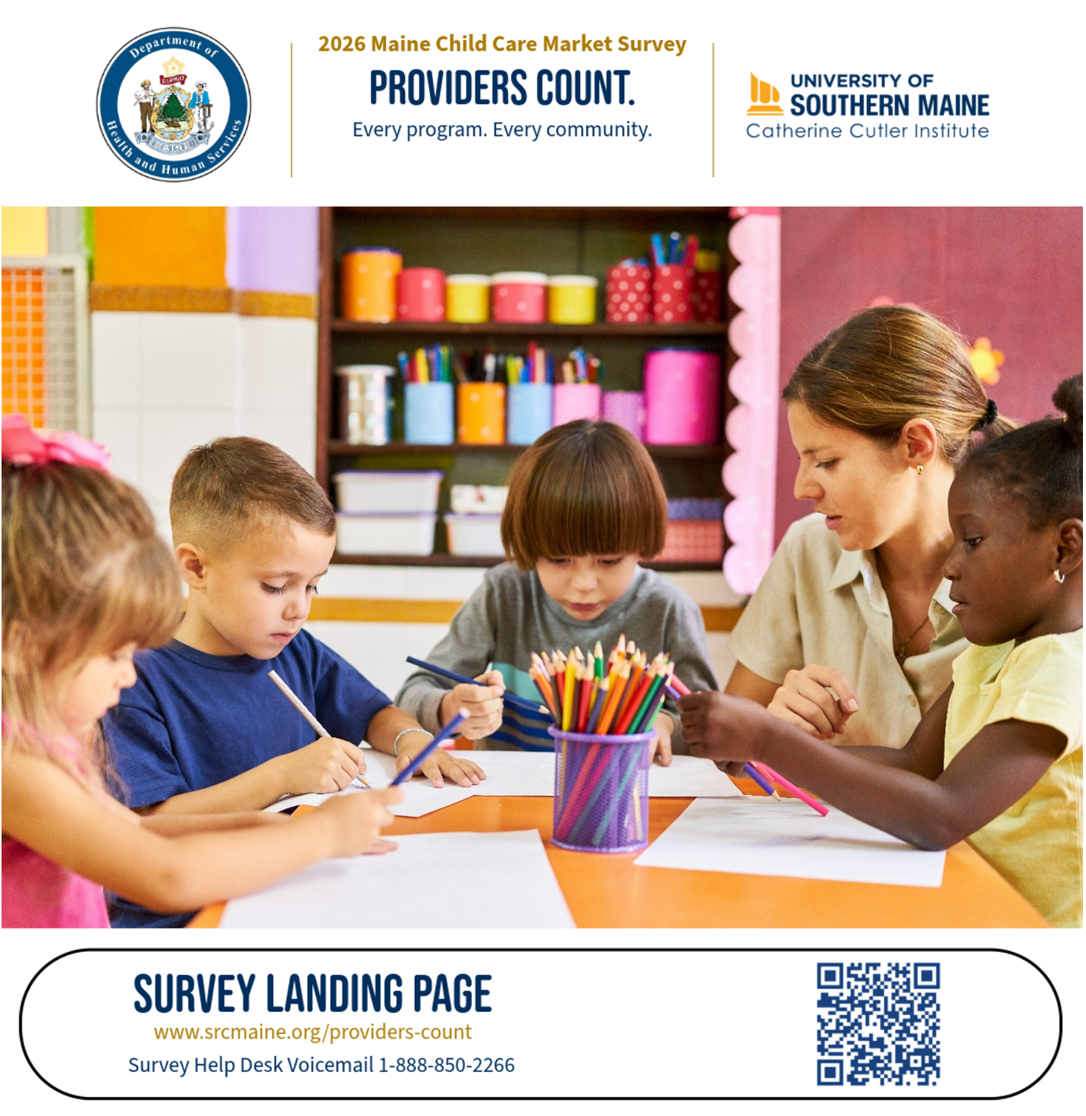

You know what it takes to provide quality child care. Now it's your turn to be counted.

The 2026 Maine Child Care Market Rate Survey is now open. A few minutes today helps ensure the experiences of providers like you are included in Maine's understanding of today's child care market.

Campaign 3: October 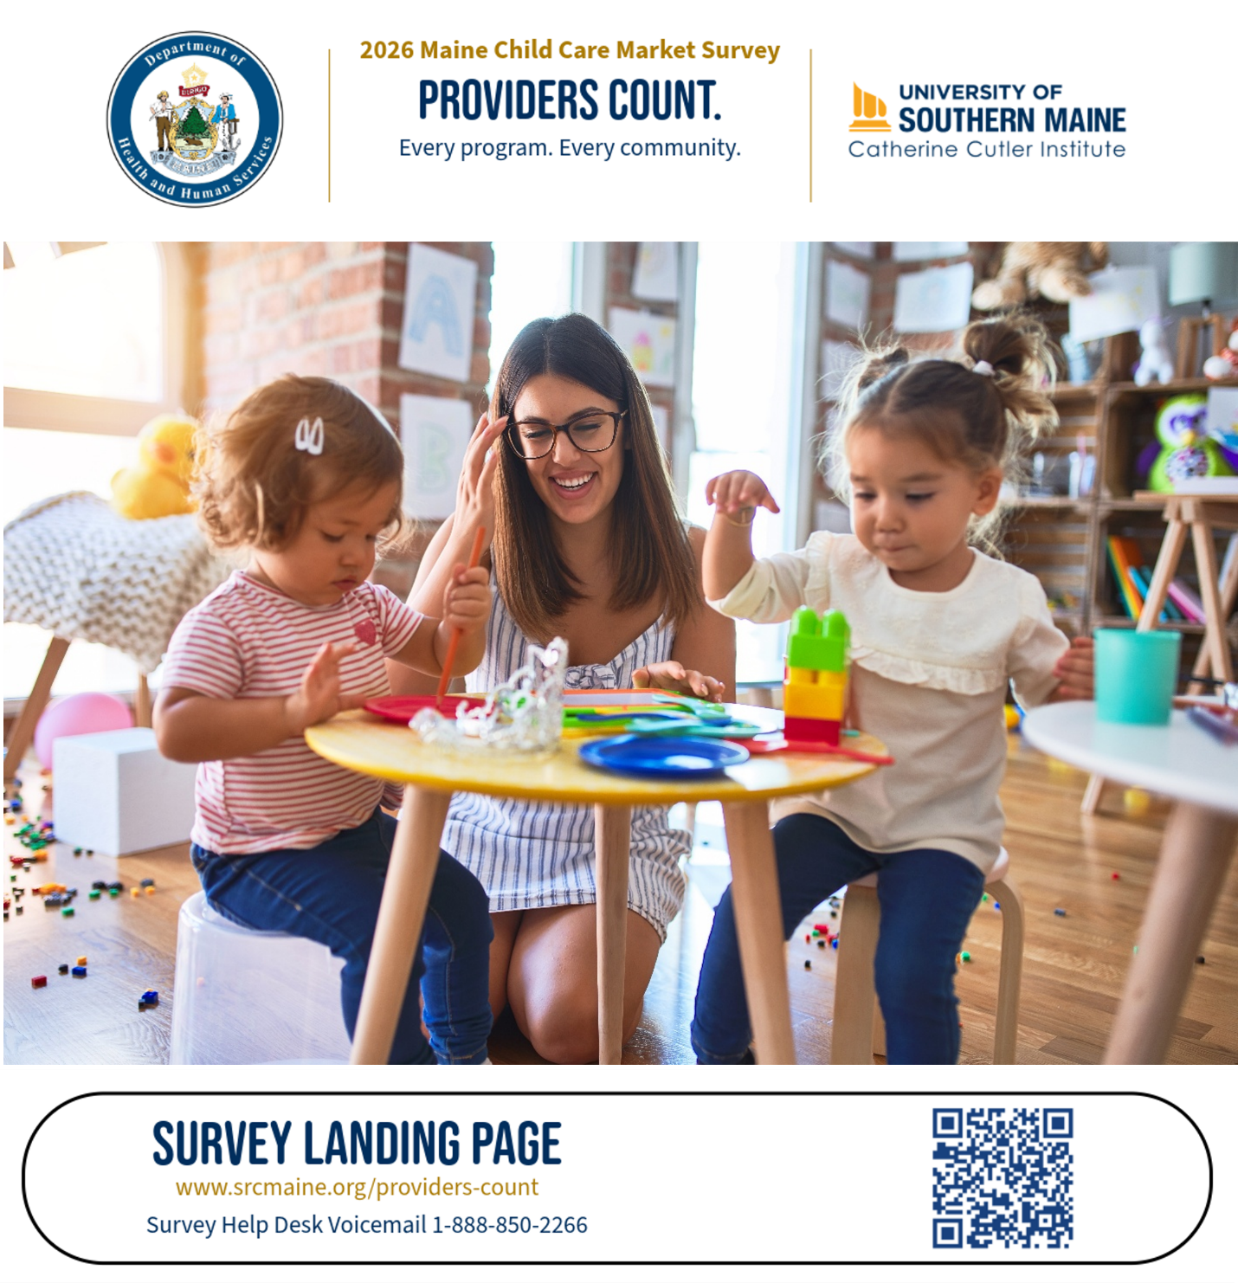

Thank you to everyone who participated. There’s still time to complete the 2026 Maine Child Care Market Rate Survey. Your experience matters—whether you operate a family child care home, a center, a nursery school, or a school-age program. Every completed survey helps build a more complete picture of child care across Maine.

Campaign 4: Late November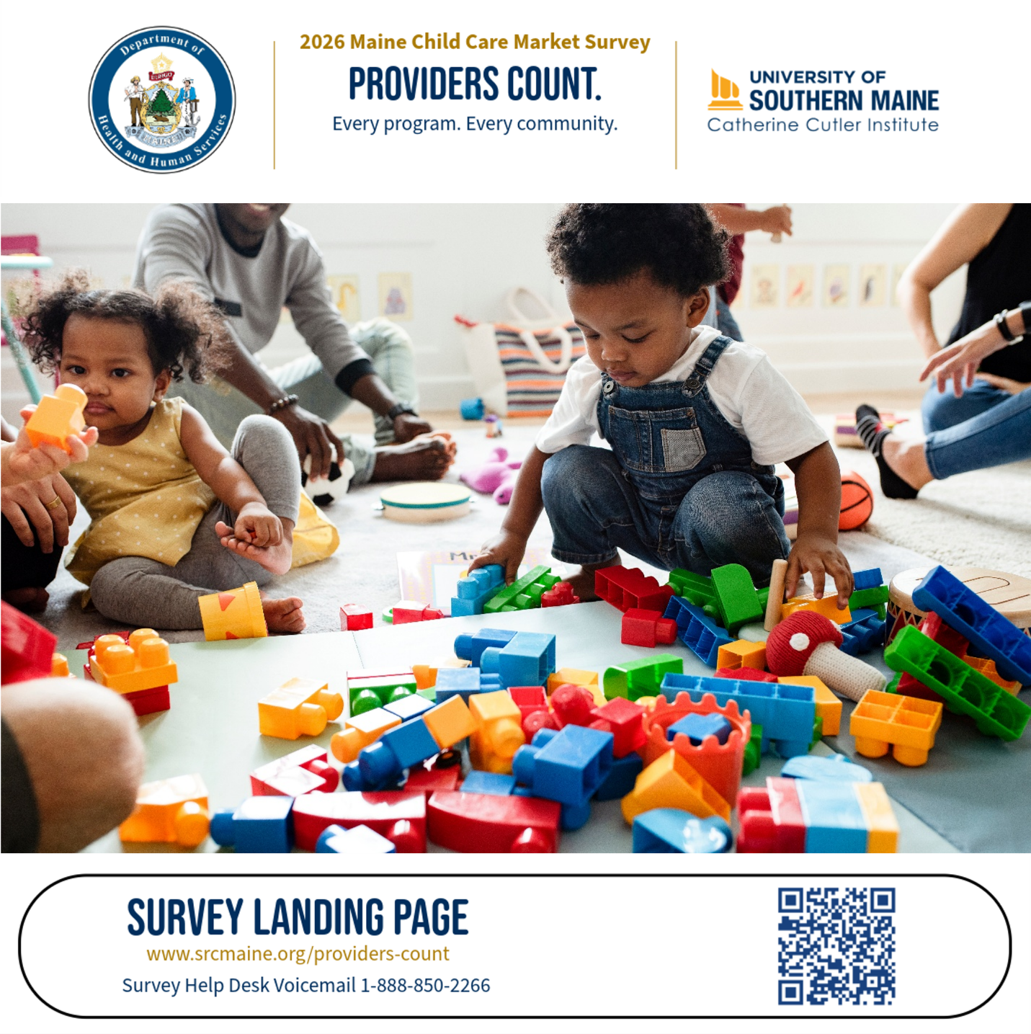

Need a hand? We're here for you.

If you've misplaced your survey invitation, need a replacement survey link, or have questions about completing the survey, we are ready to help. Call the Survey Help Desk Voicemail at 1-888-850-2266. Leave a message and let us know the best time to reach you. We are available some evening and weekend hours as well as during normal business hours. A member of the Survey Research Center team will return your call promptly.

The survey closes December 1. We hope you'll take a few minutes to participate.

